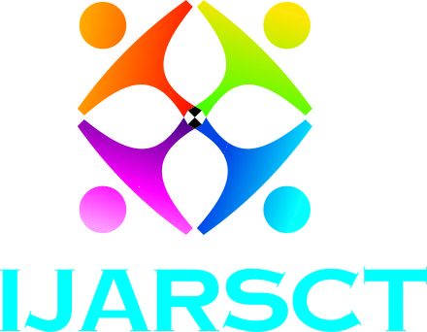
IJARSCT
ISSN (Online): 2581-9429

International Journal of Advanced Research in
Science, Communication and Technology
www.ijarsct.co.in
DOI 10.48175

COPYRIGHT AGREEMENT
In order to publish your article we need your agreement in written format. Please complete and sign the form and send it with the final version of your manuscript. It is required to obtain copyrights for papers published in the journal so as to index them to various repositories.

Title of Paper:
____________________________________________________________________________

Author(s):
____________________________________________________________________________

I/We undersigned hereby transfer any and all rights in and to the paper including without limitation all copyrights to the International Journal of Advanced Research in Science, Communication and Technology. I/We undersigned hereby represents and warrants that the paper is original and that he / she is the author of the paper, except for material that is clearly identified as to its original source, with permission notices from the copyright owners where required. I/We undersigned represents that he / she has the power and authority to make and execute this assignment.
Authors have full rights to submit a copy of their published papers to all open access repositories. They can self-archive both their original and /or journal published versions.
This agreement is to be signed by at least one of the authors who have obtained the assent of the co-author (s) where applicable.

Author Signature & Name: ____________________________________________________

Date: _____________

Institution or Company Name: ________________________

Mail to: ijarscted@gmail.com

